GOOD OLD-FASHIONED FUN!!!
Dutch Oven and Cast Iron Cow Camp Cooking
Breakfast, Lunch and Dinner Wagon Rides
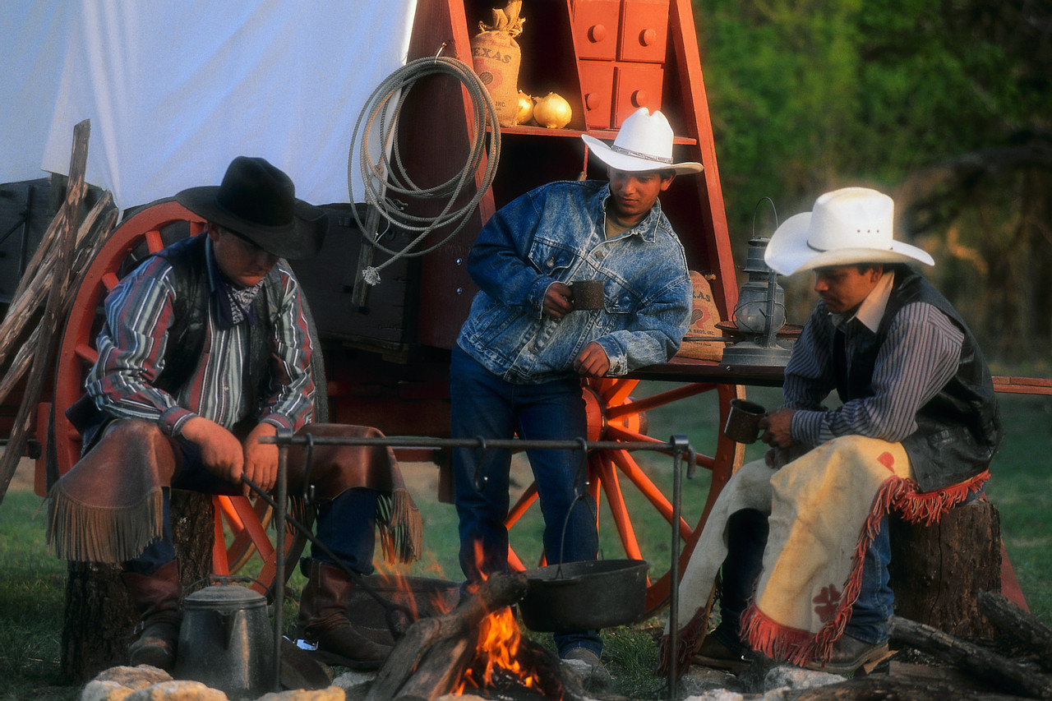
Take a trip back in time at our year-round
working/recreational ranch.

Come out and take a HORSE-DRAWN WAGON RIDE
to our COWBOY CAMPFIRE for breakfast, lunch or dinner.
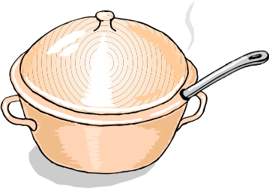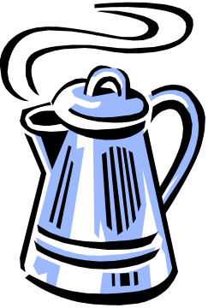
GREAT TIME
GREAT FOOD*
GREAT DEAL
* Dinner ride includes 16 ounce porterhouse steak cooked on the open fire,
baked Idaho spud, pasture greens, Dutch oven baked beans, sourdough rolls, cow-chip cookie or vinegar pie, and spring water lemonade or old-fashioned camp coffee.
For prices, times, directions, and breakfast or
lunch menus, check out our website at:
www.mmranchfun.com
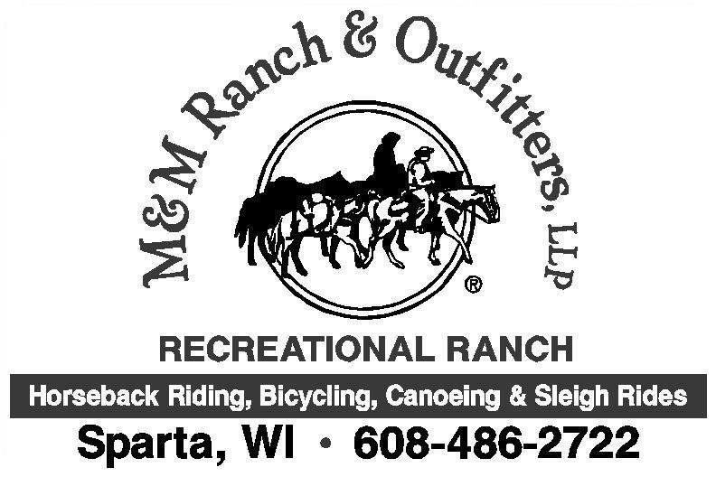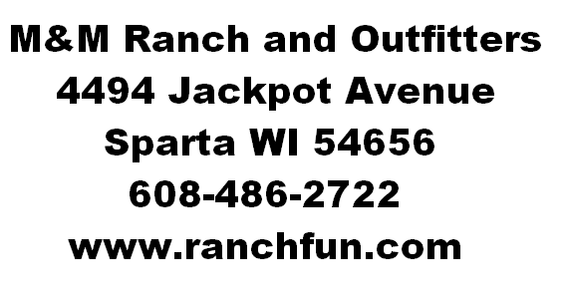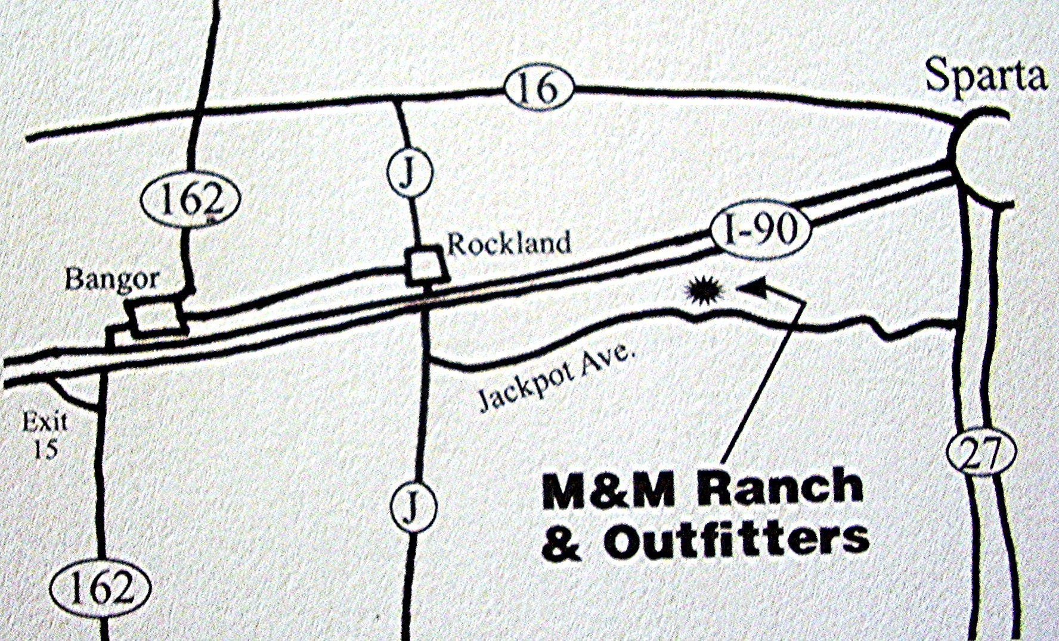
To serve you best, reservations are required.

Breakfast menu:
scrambled cacklin’s
pig-squealing sausage or bacon
the camp cookie’s Texas toast
sourdough pancakes
old-fashioned camp coffee or sunshine squeezin’s
Price: $

Lunch menus:
hot dogs in buns or hamburger steak sandwich
chips
Dutch oven baked beans
cow-chip cookie
spring water lemonade
old-fashioned camp coffee
Price: $17 or $25

New this year ~ Dinner menu:
16 ounce porterhouse steak
baked Idaho spud
pasture greens
Dutch oven baked beans
sourdough rolls
cow-chip cookie or vinegar pie
spring water lemonade
old-fashioned camp coffee
Price: $40

